This document outlines the psychographic we intend to develop a game for.

***Name:*** Terry Goldhorn

***Age:*** 20

***Family:*** Parents are married, middle child of three brothers. No sisters.

***Favourite book:*** Eldest.

***Favourite holiday:*** Activity holiday abroad with family.

***Pets:*** Dog

***Favourite alcoholic drink:*** IPA

***Morning or night person:*** Night person

***Hobbies:*** Football, swimming, playing video games, walking the dog.

***Proudest accomplishment:*** Won a trophy in a football tournament.

***Things to do for relaxation:*** Play games with friends

***Favourite phone app:*** Pokémon GO

***Fears:*** Spiders

***Occupation:*** Student / Part-time retail worker at Tesco Express.

***Course:*** Sport Science

***Educational Level:*** Undergraduate

***Educational Institute:*** University of East Anglia

***Clothes:*** Casual wear, shops at places such as Primark, ASDA, Tesco, etc.

***Favourite Colour:*** Blue.

***Favourite Food:*** Pasta

***Favourite Takeaway:*** Chinese

***Bedroom Aesthetic:*** Walls are plain white, with a grey carpet. Very few posters of video games and films on the wall. Couple of plants on desk, windowsill and bookcase. Has practical items in his room, doesn’t clutter up space.

***Favourite Band:*** The White Stripes

***Favourite Music Genre:*** Indie

***Favourite Song:*** Lonely Boy – The Black Keys

***Favourite Film:*** Mission Impossible III

***Favourite Actor:*** Jason Statham

***Favourite TV character:*** Jake Peralta

***Favourite Film Genre:*** Action/Thriller

***Favourite Television Program:*** The Iron Fist

***Media Consumption:*** Streaming services (Netflix, YouTube, Spotify and Twitch)

***Favourite Video Game Console:*** Microsoft Xbox One

***Favourite Video Game:*** Gang Beasts

***Favourite time to play games:*** Evenings

***Favourite people to play with:*** Friends / Housemates

***Drivers Licence:*** Full-licence.

***Does Terry own a car:*** 2004 Volkswagen Polo in blue

***Dream Car:*** Ferrari Enzo

***Phone Make:*** iPhone 8

***Work Ambition:*** Physical Education Teacher

***Life Ambition:*** Wants to have his own home and a family by 30 years of age.

***Where does Terry want to live after graduation:*** London, Lewisham.

***Where does Terry reside:*** Shared student house.

***Where* *does Terry play:*** Terry plays on the Nintendo Switch, Xbox One and Windows PC a so he is able to invite friends over to play at his, play online with his friends or he can take his Nintendo Switch to a friend’s house and play there. Terry could also take the Switch to University to play with his friends there.

***When* *does Terry play:*** Terry will mainly be available to play games in the evening once he has finished any University work that needs to be completed and any chores are done. However, because Terry owns our game on his Nintendo Switch he can take the console and play anywhere he has around 10 minutes spare with some friends.

***With who* *does Terry play with*:** Terry mainly plays with his friends over Xbox Live although he does like to invite friends over to play cooperative games together.

***How often* *can Terry play*:** Terry generally plays most evenings of the week, although he does enjoy going out and doing activities with his friends and family.

***Games Terry Plays: (Platform Terry owns game on)***

* Pirates of the Caribbean (Microsoft Xbox original).
* Assassins Creed: Black Flag (Microsoft Xbox One).
* Raiders of the Lost Island (Windows PC).
* Overcooked (Nintendo Switch).
* Gang Beasts (Windows PC).
* Super Mario Party (Nintendo Switch).
* Mario Kart 8 (Nintendo Switch).
* Catastronaut (Xbox one).
* Lovers in a Dangerous Place (Microsoft Xbox one).
* Guns of Icarus (Windows PC).
* Pixel Piracy (Windows PC).
* Sid Meire’s Pirates (Windows PC).

***Day Plan for Terry Goldhorn***

Wakes up at 6:30AM to go for a morning run. Home to have a shower and eat breakfast by 7:30AM. Leaves at 8:40AM to get to morning lecture. Lectures run from 9:00AM – 12:00PM. Spends an hour in the library doing research. Goes home to get changed and prepare to leave for his job at Tesco starting at 2:00PM finishing at 6:00PM. Gets home at 6:30PM to get ready to meet up with housemates for food. Gets home around 8:00PM and plays some video games to unwind from the day.

***Picture of Terry:***

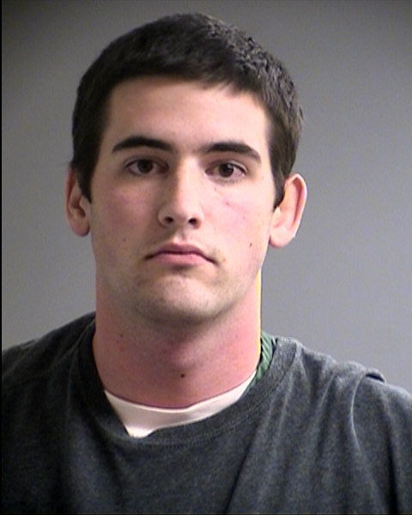

***Picture of Terry’s car:***

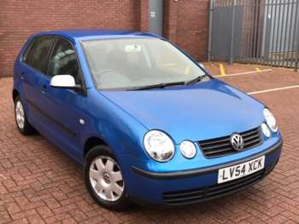

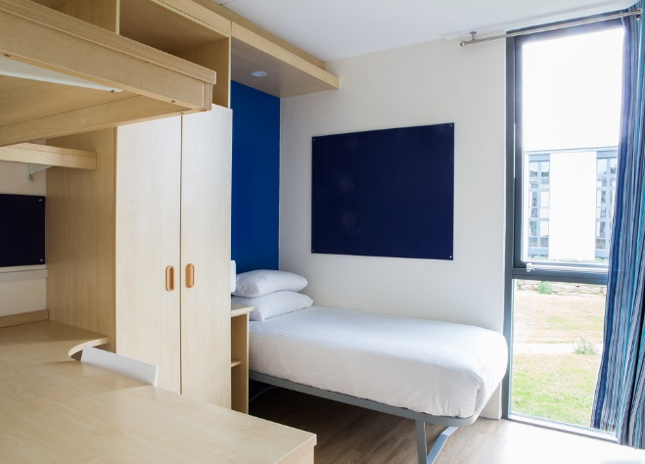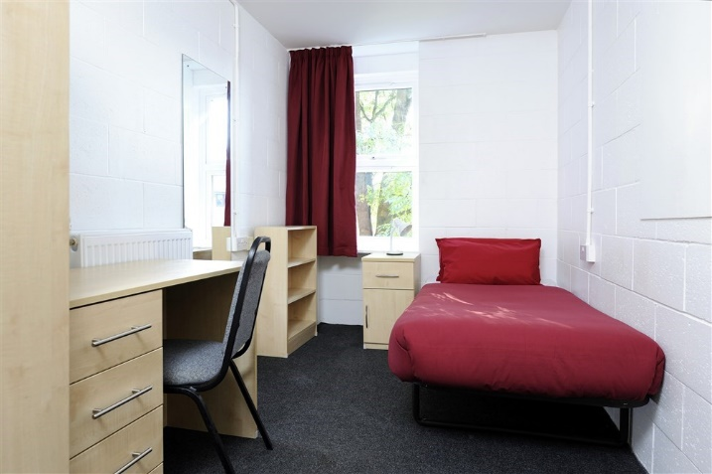**Bedroom Mood Board**

